User Guide

Prevention of Family Violence Data Platform

June 2023



CONTENTS

Introduction 3

Section 1: General navigation 4

1.1 The four panels 4

1.2 Accessing the update log 5

1.3 Top menu bar 6

1.3.1 Indicators and data 7

1.3.2 Introduction 7

1.3.3 About the data 8

1.3.4 Publications and resources 8

1.3.5 User Guide and FAQs 9

1.3.6 Contact 9

1.4 Icons and arrows 10

Section 2: Exploring the data 12

2.1 Navigating the Thematic pages 12

2.2 Navigating the Free from Violence Outcomes Framework 14

2.2.1 Selecting an outcome and indicator 14

2.2.2 Navigating the data pages 15

2.2.3 Selecting the topic of interest 16

2.2.4 Downloading the data or view it as a table 16

Section 3: Using the search function 17

3.1 Searching by outcomes and indicators 17

3.2 Searching by keyword 18

# **Introduction**

This user guide is made up of three sections with step-by-step instructions and screenshots on how to navigate the Prevention of Family Violence Data Platform (Data Platform).

**Section 1: General navigation** will show you what each panel on the home page relates to, the top menu bar and how to move around the Data Platform using the different icons.

**Section 2: Exploring the data** will show you two different ways to access data. This can be done through the thematic pages or through the four Outcomes of the [Free from Violence Outcomes Framework](https://www.vic.gov.au/free-violence-victorias-strategy-prevent-family-violence).

**Section 3: Using the search function** will show you how to utilise the Data Platform’s search feature to find the right data quickly.

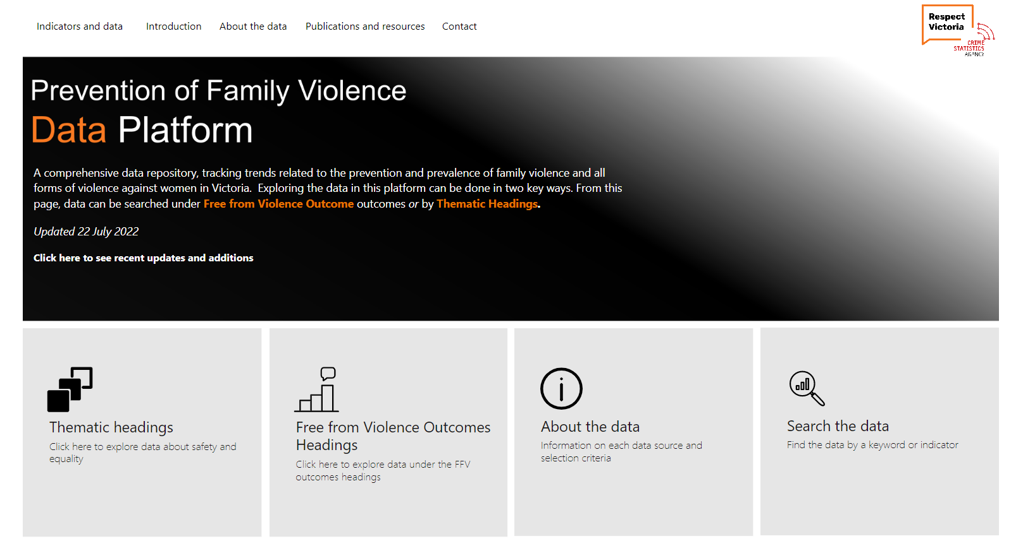

The Data Platform can be accessed via the:

* [Respect Victoria website](https://www.respectvictoria.vic.gov.au/prevention-of-family-violence-data-platform) or
* Directly via this link:

<https://files.crimestatistics.vic.gov.au/Prevention-of-Family-Violence-Data-Platform.html>

For any feedback or questions please email Respect Victoria at [practice@respectvictoria.vic.gov.au](mailto:practice@respectvictoria.vic.gov.au)

# Section 1: General navigation

The Data Platform is powered by Power BI and is not web based. This means that you **cannot** use the **page navigation buttons on your web browser to move between pages.** Doing this will result in exiting the Data Platform.

To navigate across the Data Platform, you will need to use the **top menu bar** options or the arrow icons (see 1.4).

## The four panels

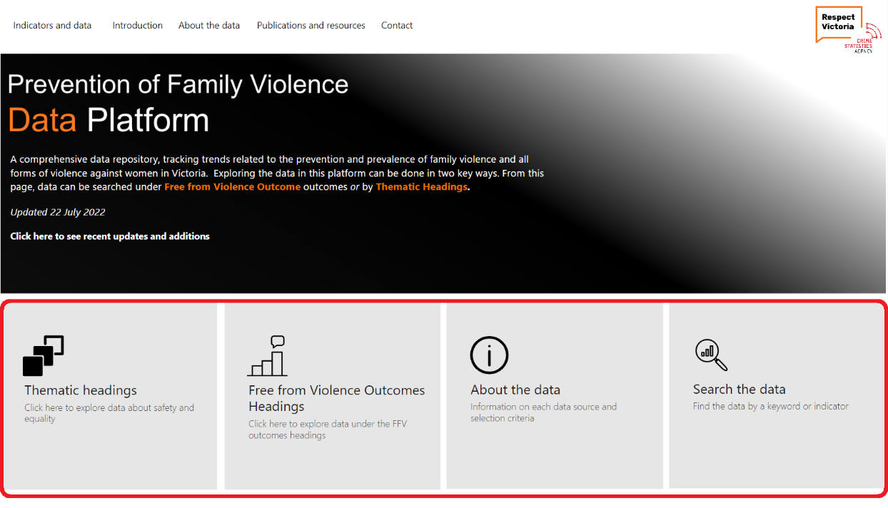

The Data Platform home page has four main panels. Clicking on each panel will take you to a specific page:

* **Thematic headings** will take you through a theme focused pathway to find data related to *safety and levels of violence* and *equality and inequality*.
* **Free from Violence Outcomes headings** will take you through a pathway under the outcomes and indicators from the Victorian Government’s [Free from Violence](https://www.vic.gov.au/free-violence-victorias-strategy-prevent-family-violence) Outcomes Framework.
* **About the data** provides you with a summary of each data source, as well as the data inclusion criteria.
* **Search the data** enables you to search for data using keywords or by the Free from Violence outcomes and indicators.

## Accessing the update log

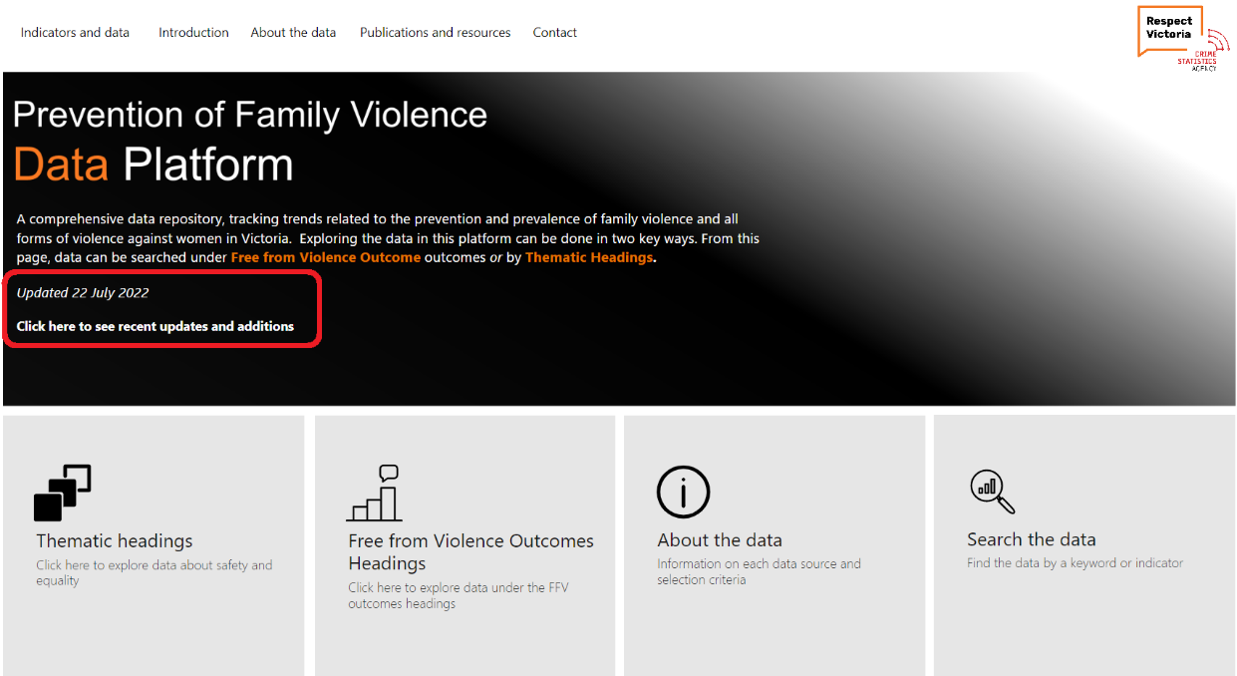

On the home page, you can access the most recent data updates. Clicking on **Click here to see recent updates and additions** will take you to the **Introduction** page where you can view the updated data for the year. The Data Platform is updated annually in June.

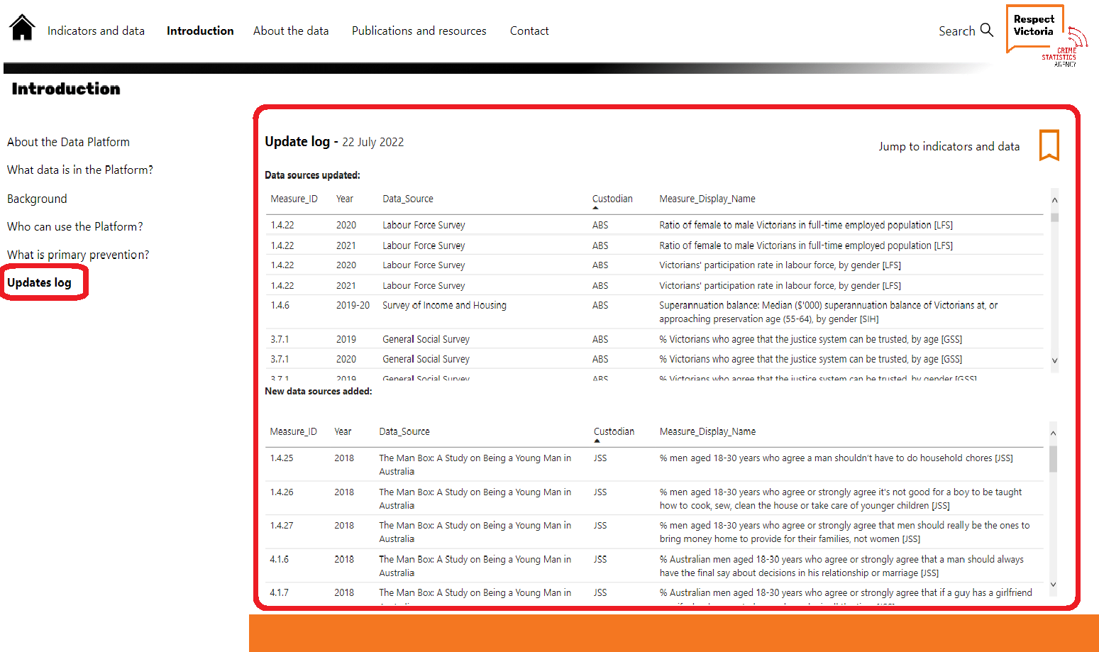

Clicking on the **Jump to indicators and data** icon will take you directly to the **Indicators and data** landing page.

## Top menu bar

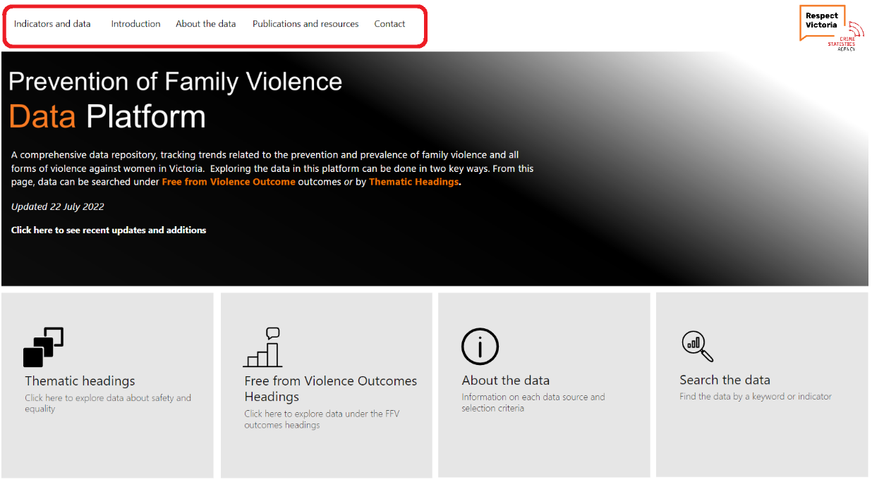

The top menu bar includes **Indicators and data, Introduction, About the data, Publications and resources,** and **Contact**. Clicking on any of these options will take you to the relevant page (see 1.3.1-1.3.6).

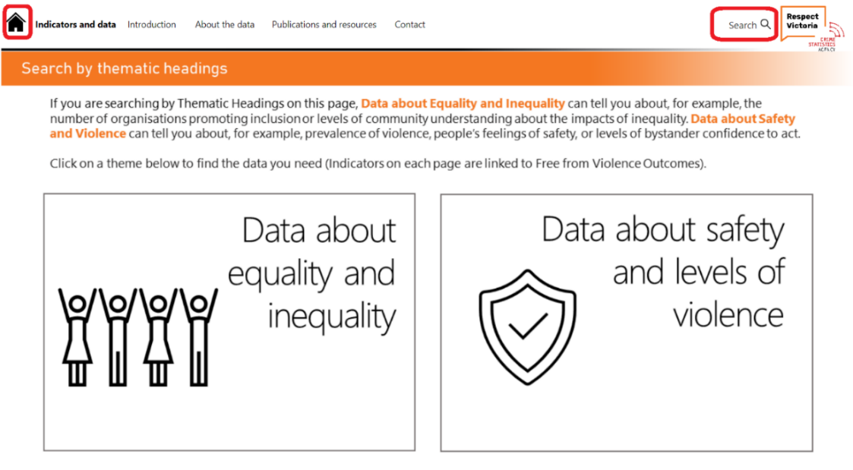

On every other page (except the home page) the top menu bar will also include the **Home** and **Search** icons. Clicking on the **Home** icon will take you back to the home page and the **Search** icon will take you to the search page (see Section 3).

### 1.3.1 Indicators and data

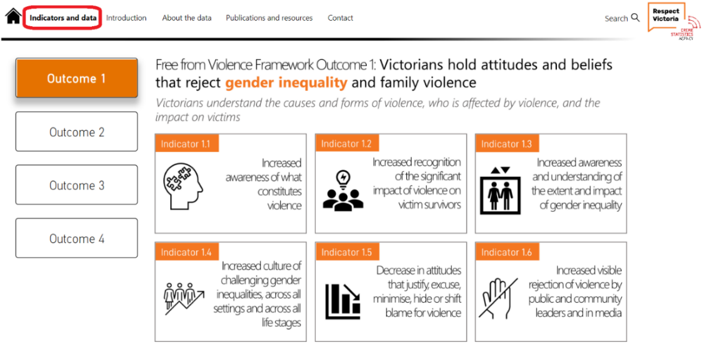

**Indicators and data** will takeyou to the [Free from Violence](https://www.vic.gov.au/free-violence-victorias-strategy-prevent-family-violence) Outcomes Framework landing page. From here you can choose the outcome and indicator you are interested in.

### 1.3.2 Introduction

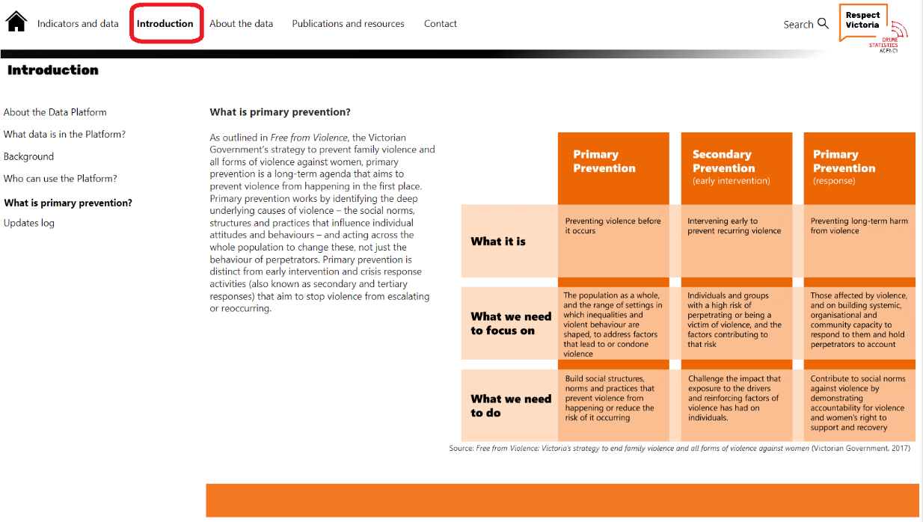

**Introduction** will take you to the background information about the Data Platform, the purpose of the Data Platform, what data is included, who can use it, what primary prevention is, and a record of data updates.

### 1.3.3 About the data

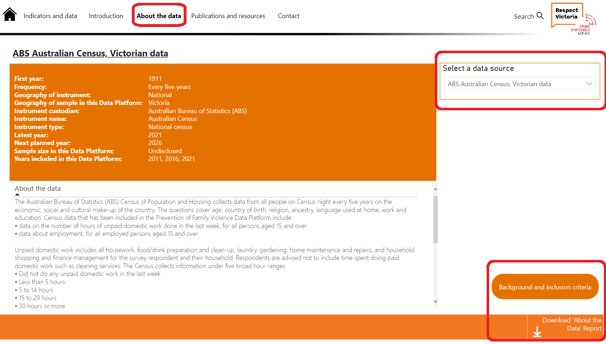

**About the data** takes you to the summary of data sources page. Click on **Select a data source** (e.g., a survey or report) drop-down menu on the right will let you choose and view details of each data source. Click **Background and inclusion criteria** to return to the previous **About the data** page. A pdf report with all data source information can be downloaded by clicking **Download** ‘**About the Data’ Report**.

### 1.3.4 Publications and resources

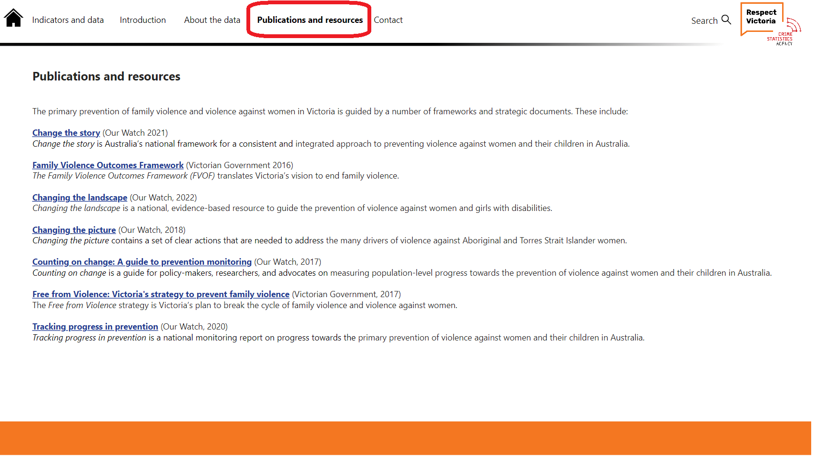

**Publications and resources** provide links to key publications referenced in the Data Platform.

### 1.3.5 User Guide and FAQs

[Placeholder for screenshot]

The **User Guide and FAQs** pageis where you will find this document as well as a Frequently Asked Questions (FAQs) document. You can download these documents.

### 1.3.6 Contact

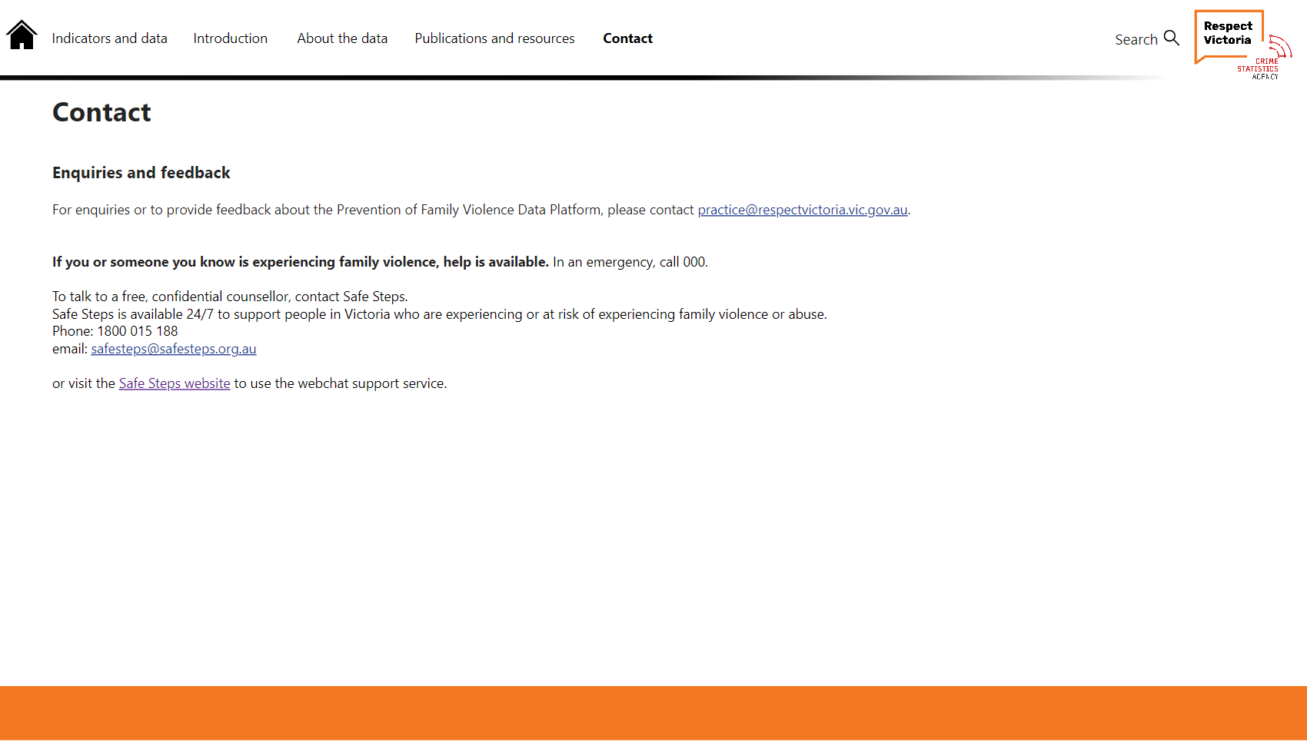

The **Contact** page provides contact details for enquiries and feedback to Respect Victoria and contact information for people experiencing violence is also provided.

## Icons and arrows

Hovering your mouse over icons will tell you where it will take you.

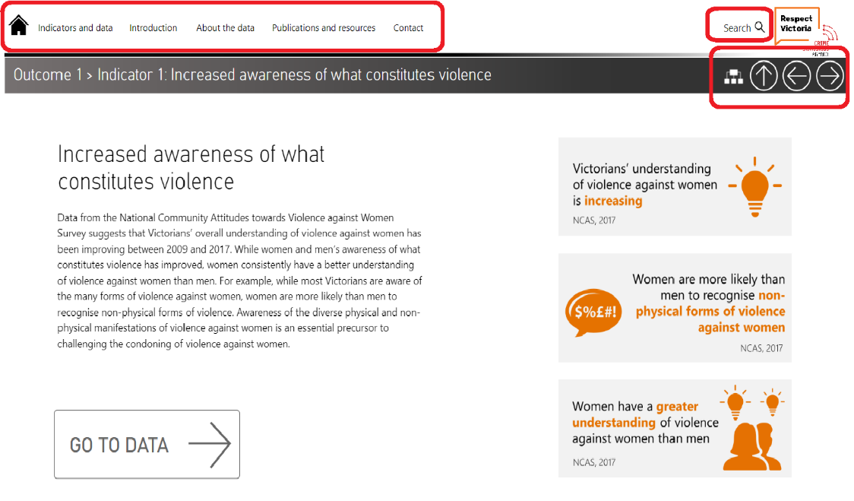

 Clicking on this icon will take you back to the **Search by thematic headings** page.

 Clicking on this icon will take you back to the previous page. This will depend where you are on in the Data Platform.

If you are on the data pages this will take you back to the indicator introduction page and not the previous measure.

 Clicking on this icon will take you the previous or earlier measure page.

If you are on the data introduction page, clicking this will take you to the next indicator introduction page.

 Clicking on this icon will take you to the next measure page.

If you are on the data introduction page, clicking this will take you to the previous indicator introduction page.

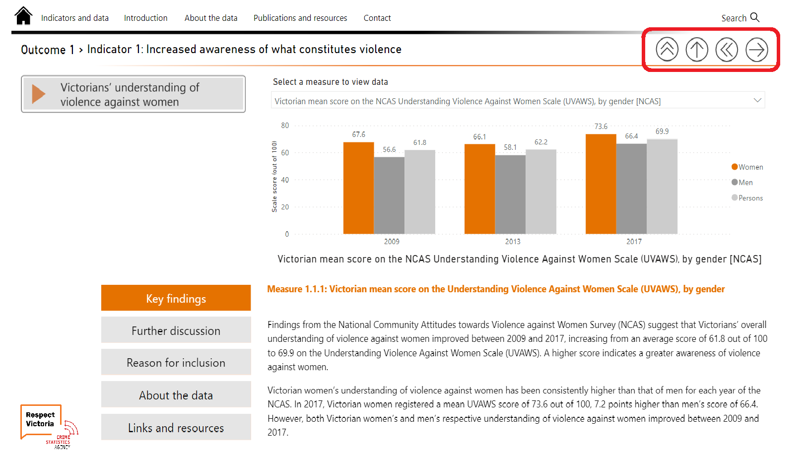

 Clicking this icon will take you back the Outcomes overview page.

 This icon is only found on measure page 1.1.1. Clicking this icon will take you to the Data Platform’s last measure page (4.6.10)

 This icon is only found on measure page 4.6.10. Clicking this icon will take you to the Data Platform’s first measure page (1.1.1)

# Section 2: Exploring the data

## 2.1 Navigating the Thematic pages

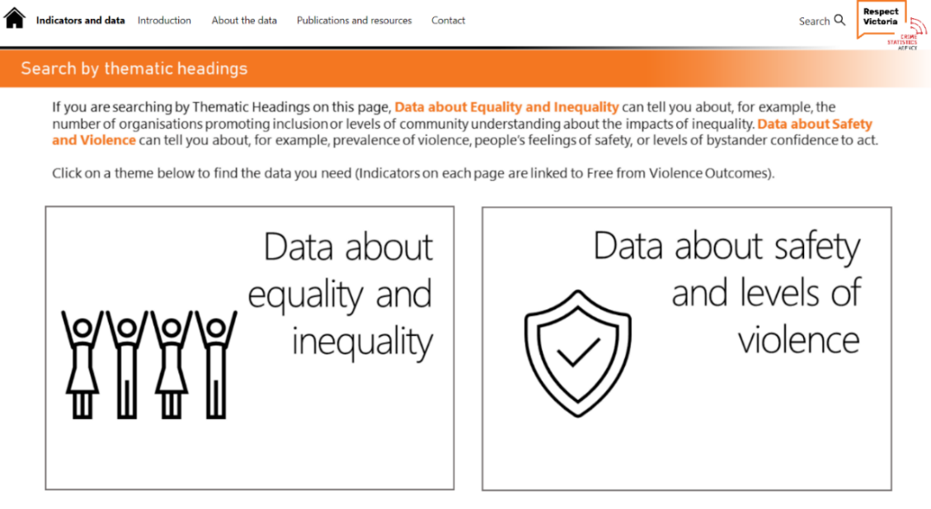

Clicking on the **thematic headings** on thehomepage will allow you to search by the following themes: **Data about equality and inequality** or **Data about safety and levels of violence**.

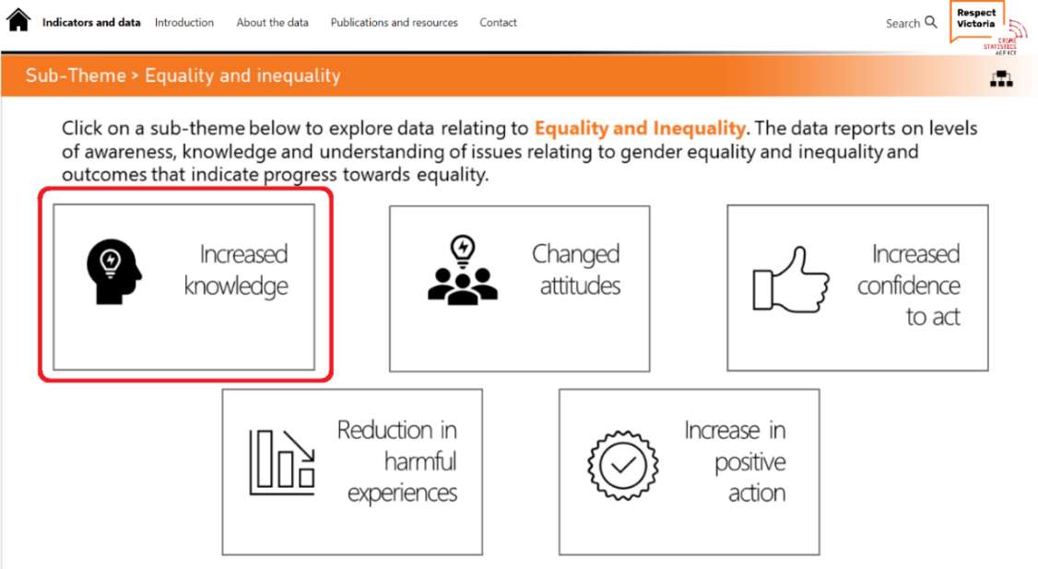

Clicking on a **thematic heading** will be take you to a **sub-theme** page that will have five sub-themes to choose from. Clicking on a sub-theme will take you to the next page, where you can choose what type of data (indicator) you are interested in. Only the most relevant data (indicator) will be shown for that sub-theme.

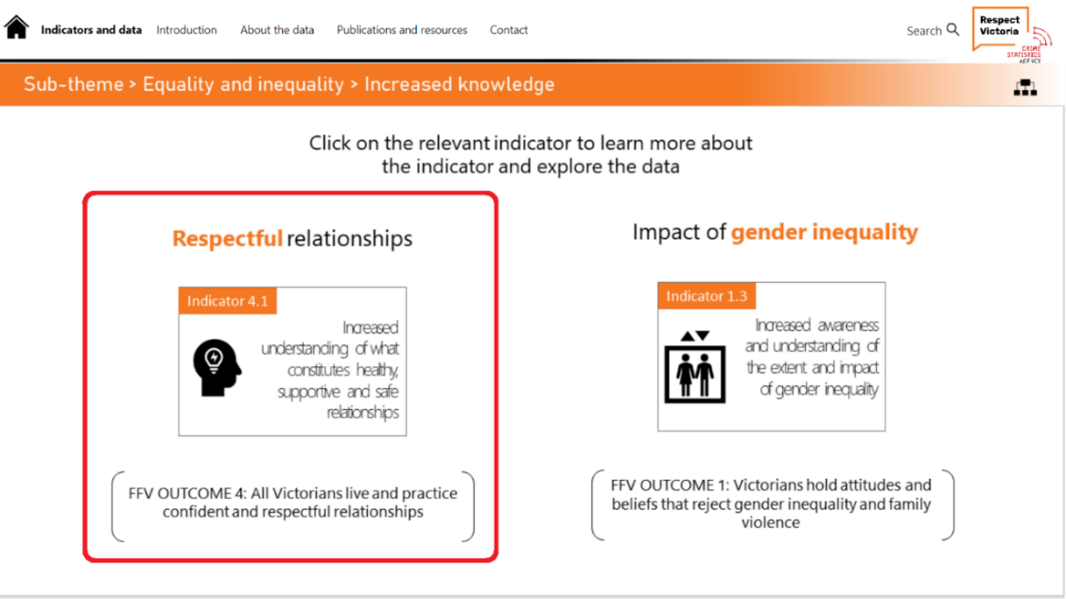

After selecting what type of data that you are interested in, you will be shown the relevant indicators relating to a specific area. In the screenshots, if you were interested in looking at data that relates to **respectful relationships**, then you would choose **indicator 4.1: Increased understanding of what constitutes healthy, supportive and safe relationships**. Clicking on an indicator will take you to the indicator introduction page, and for this example it will be **Indicator 4.1**.

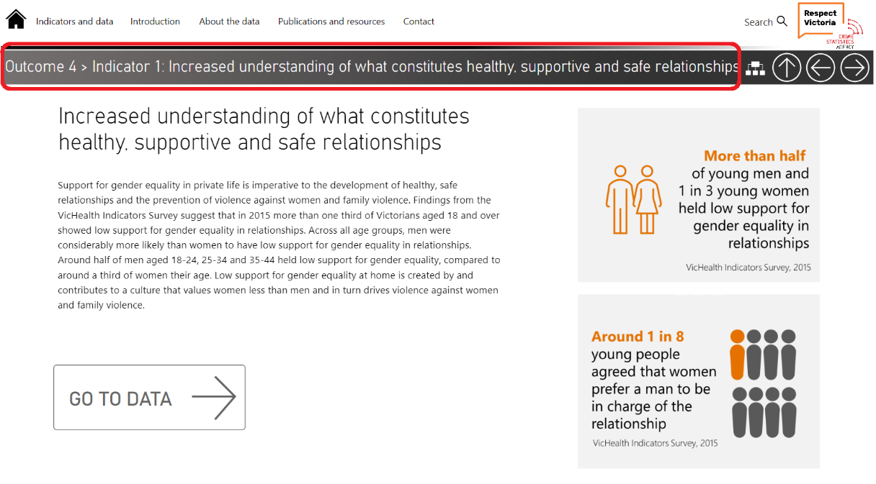

## 2.2 Navigating the Free from Violence Outcomes Framework

### 2.2.1 Selecting an outcome and indicator

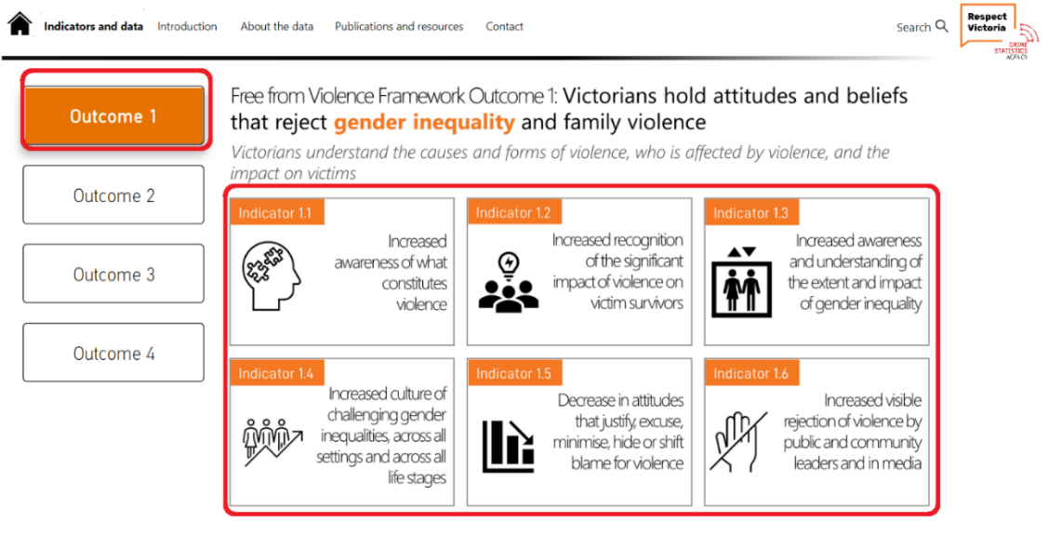

In the **Indicators and data** page you will have options to choose which Outcome you want to explore. Only once you have chosen an Outcome, can you then choose the indicator. Clicking on an indicator will then take you to the indicator introduction page.

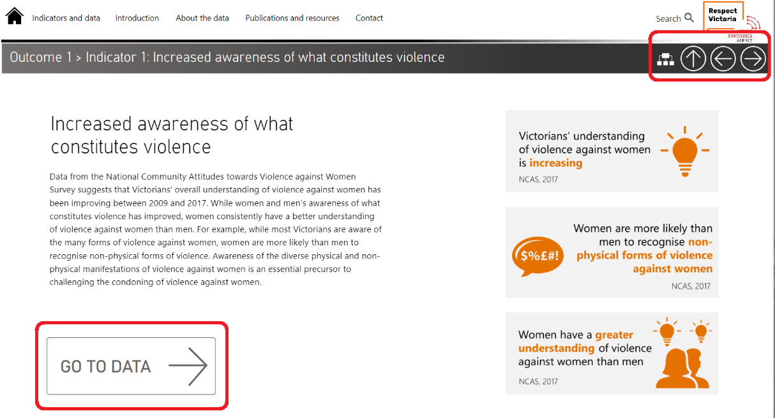

The indicator introduction page provides you with some key infographics and a narrative about the indicator. To access the data, you will need to click on **Go To Data**.

### 2.2.2 Navigating the data pages

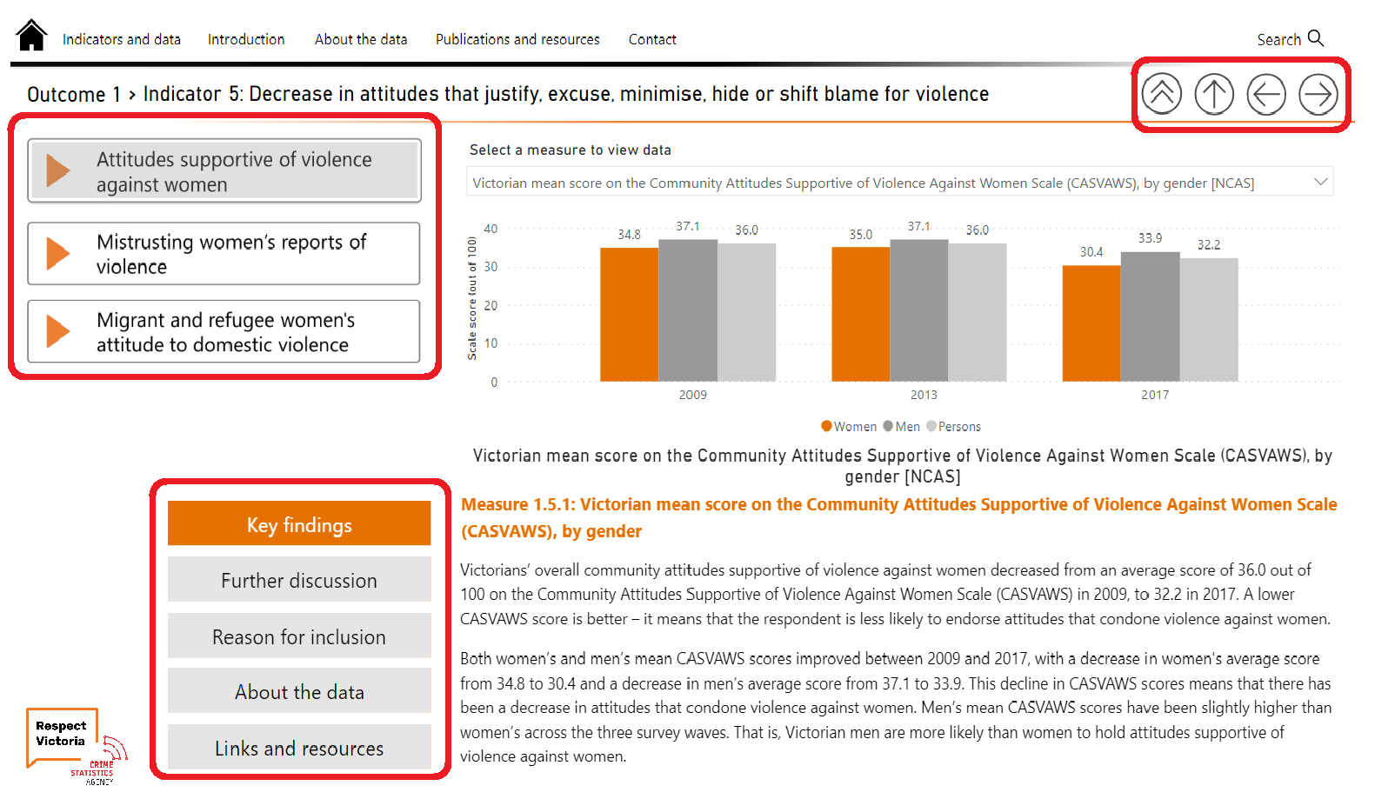

You can use the **left and right arrows** at the top of the page to move betweendata pages (see 2.4). If you are interested in a specific area, you can click on these on the left had side.

Each data page will have **Key Findings**, **Further discussion, Reason for inclusion** and **About the data**. The **Links and resources** provide hyperlinks to resources.

Hovering over the chart will bring up a **tooltip box** that provides a brief explanation of the data.

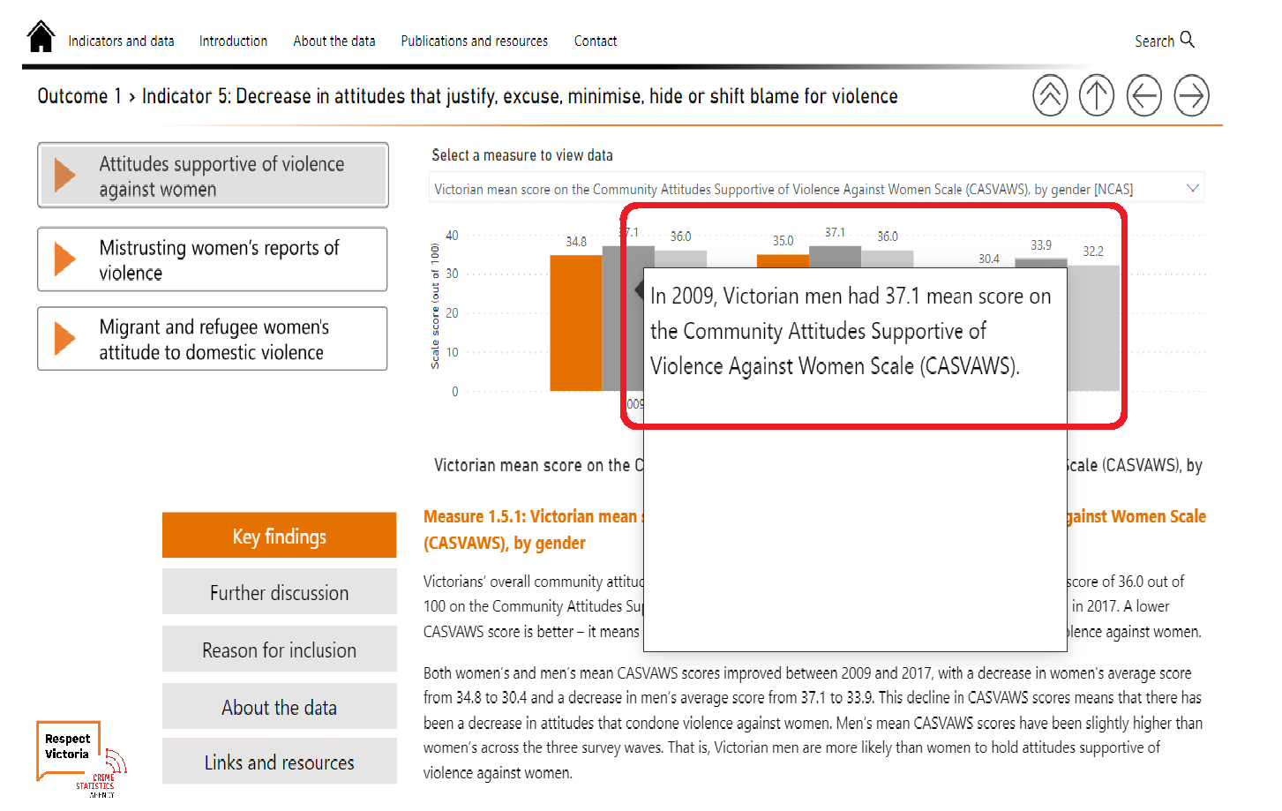

### 2.2.3 Selecting the topic of interest

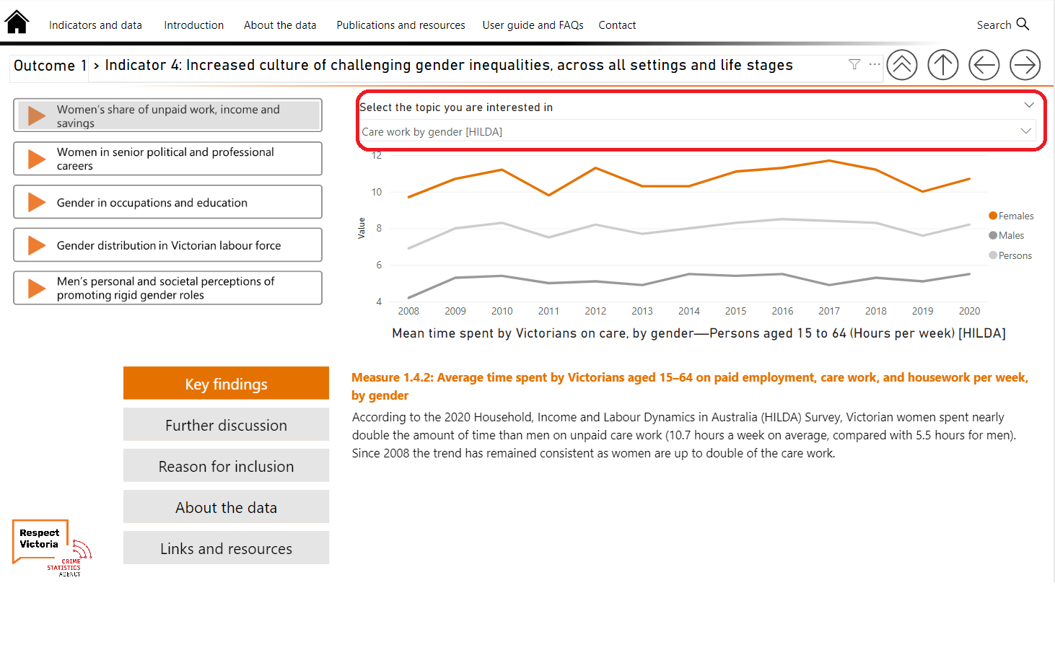

You can choose the topic you are interested in.

[More text to be added]

### 2.2.4 Downloading the data or view it as a table

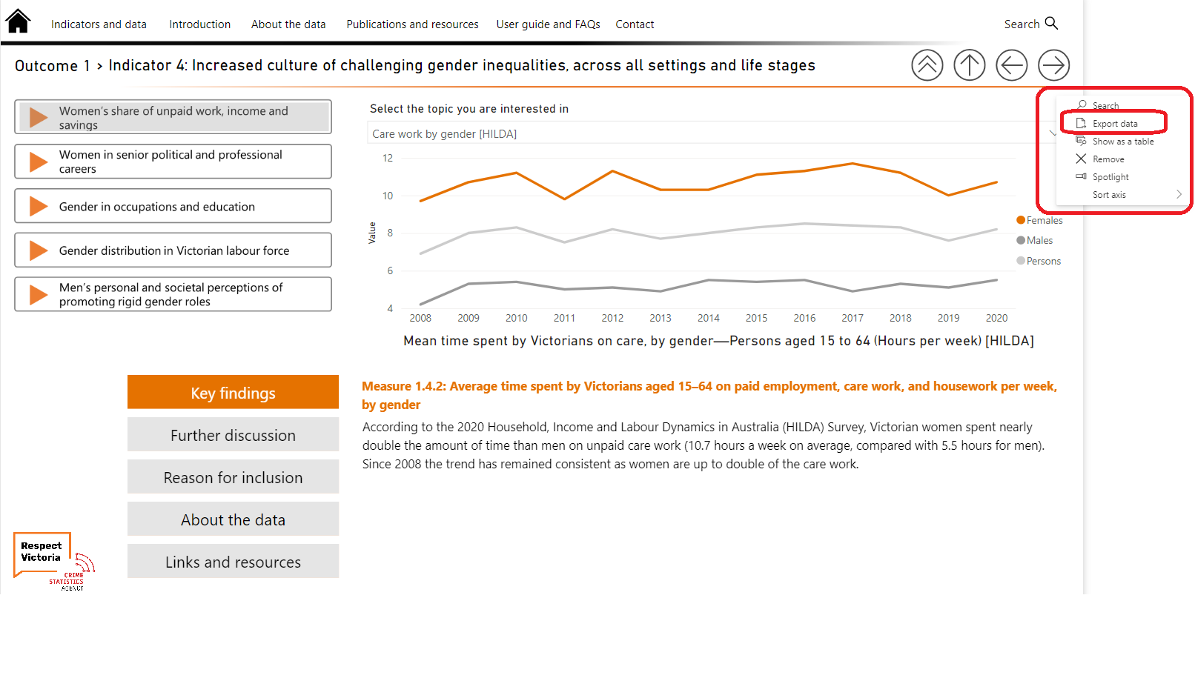

You can download a CSV file of a chart. To do this, hover the mouse on the top right of the chart and click on the three dots. From here you can then choose **Export data** as a CSV file. You can also choose to view the data as a table. To do this, hover the mouse on the top right of the chart and click on the three dots. From here you can then choose **Show as a table**. Choosing this will take you to a view of the data as a table as well as the chart. You can return to the main data page by clicking on **Back to report**.

# Section 3: Using the search function

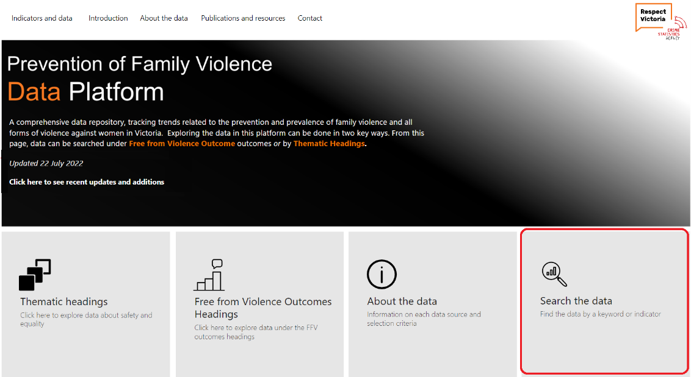

Click on **Search the data** from the home page or **Search** iconat the top of each page. Here you can **Search data by outcome or indicator** or **Search data by keyword.**

You will be able to find the relevant data from this search page. However, clicking on the indicator will not take you directly to the data page. You will need to click on **Indicators and data** on the top menu bar to get back to the data pages.

**It is recommended that you manually write down the relevant data from your search**.

## 3.1 Searching by outcomes and indicators

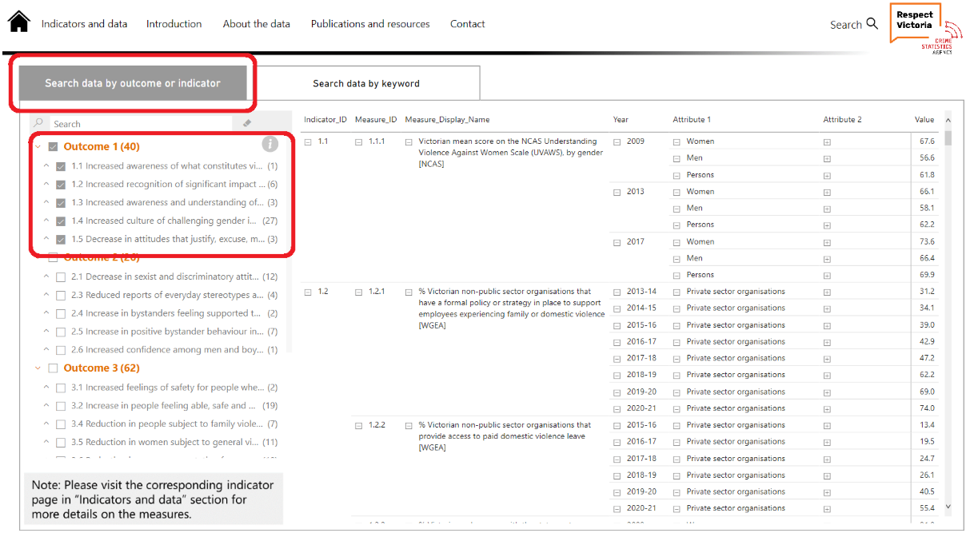

Click on **Search data by outcome or indicator** anda list of all outcomes and indicators and their measures will be displayed. You can select these using the check boxes.

The indicator measure, data type variables and percentages/amounts will be displayed on the right-hand side.

## 3.2 Searching by keyword

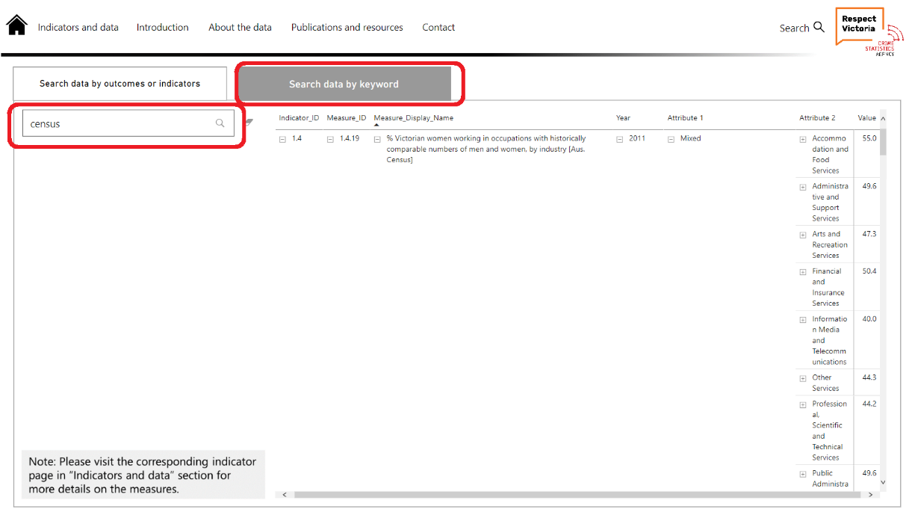

You can either type a word or an acronym into the search bar. *It is recommended that you search by acronym of organisation or survey (e.g., search PSS not Personal Safety Survey), not the full name of organisation/publisher of report*.

**Example 1:**  Searching the data by keyword ‘census’ will show all relevant measures that has the word ‘census’ in it.

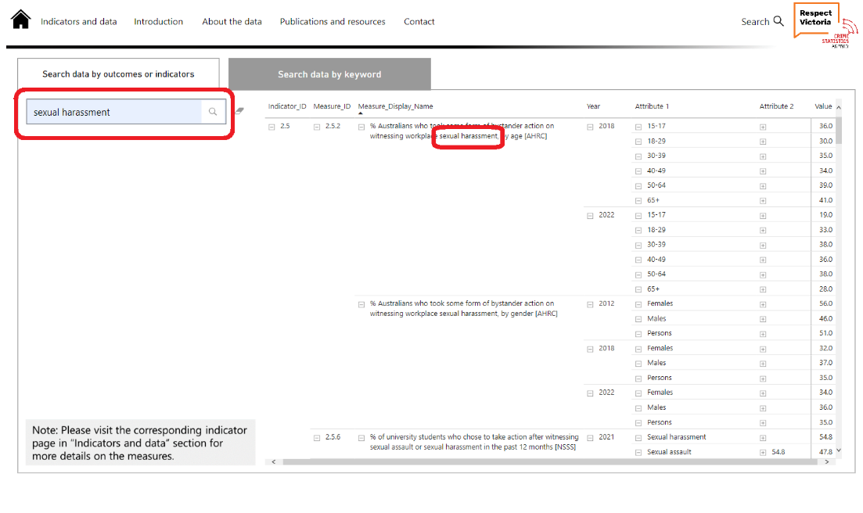

**Example 2:** Searching the data by keyword ‘sexual harassment’ will show results that have the keyword in any of the measures across the Data Platform.