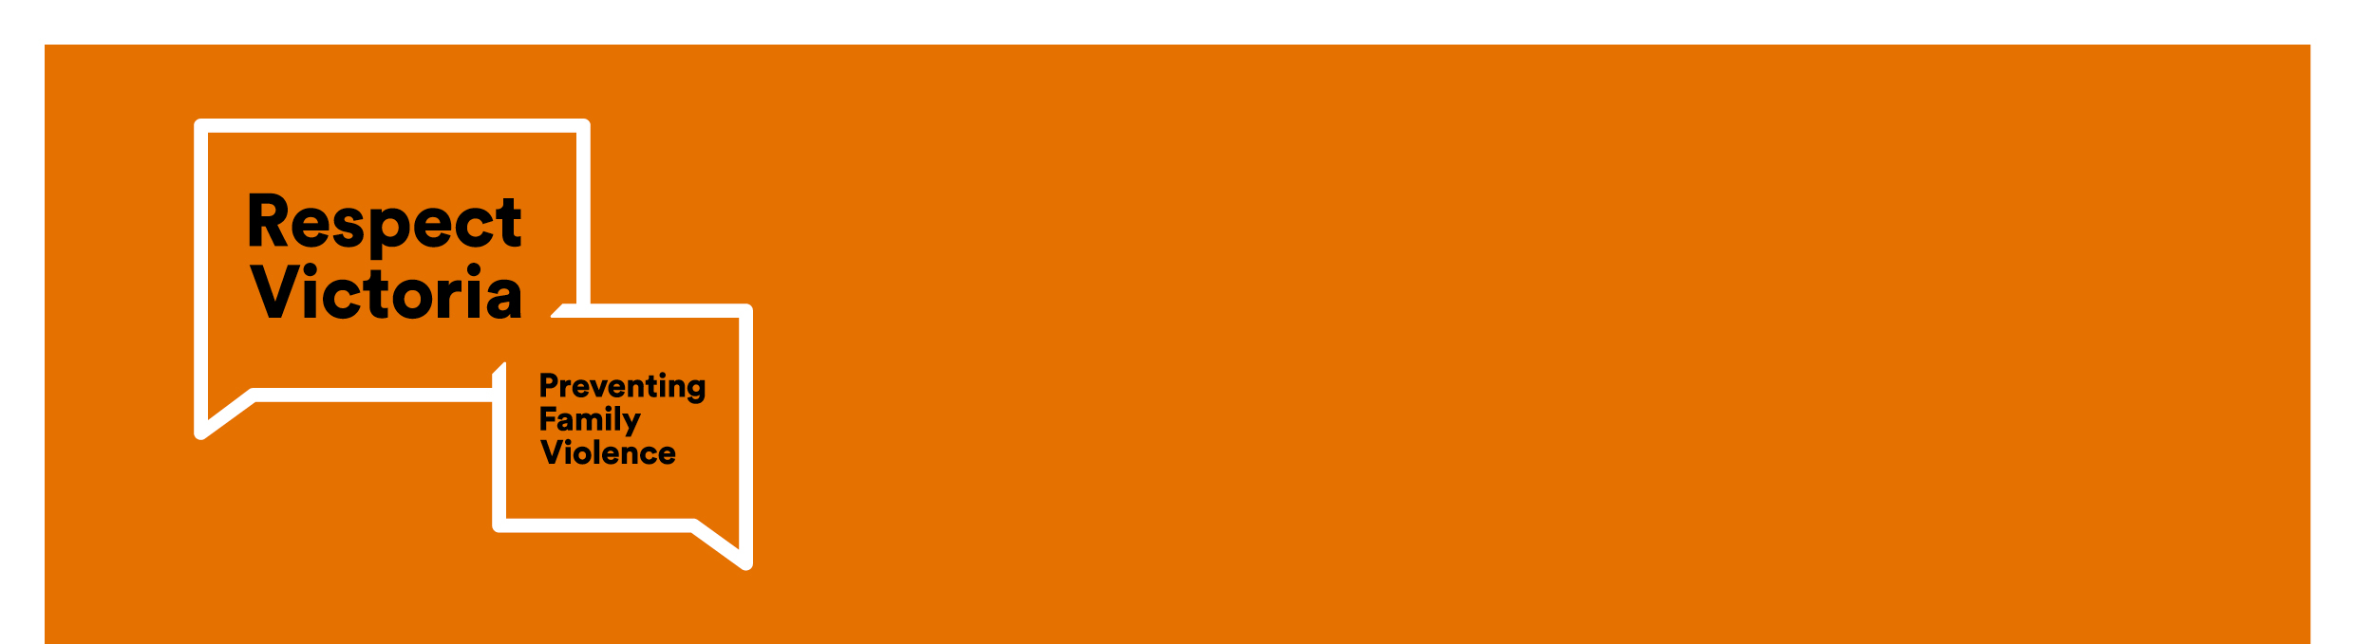

|  |
| --- |
| Respect Women: ‘Call It Out’ campaign |
|  |

# About this campaign

Men and women deserve equal rights and opportunities. This campaign focuses on respect – the most important tool we can use to take steps towards gender equality. It asks the Victorian community to think about what respect means, what it can look like in families and relationships, and how to apply it.

# How disrespect can lead to violence against women

Not all disrespect ends with violence, but all violence against women starts with disrespect. Research tells us that men who hold disrespectful views towards women are more likely to commit acts of violence against women. Challenging disrespect towards women is everyone’s responsibility.

# Examples of what disrespect towards women may look like

Here are some examples of disrespect towards women:

**In the community**

* Using gender as an insult (e.g., ‘you cry like a girl’)
* Staring at a woman or making comments that might make her uncomfortable
* When your friend speaks disrespectfully to or about his partner
* Comments about women not being good at sport or other traditionally ‘male’ activities

**In workplaces**

* Assuming a woman does or doesn’t have certain skills because she is a woman
* Sharing inappropriate images with colleagues
* Making comments or jokes that are sexual
* Expecting female colleagues to clean the work kitchen or get tea/coffees if it is not their role to do that

# How to call out disrespect towards women

By calling out disrespect towards women, we can prevent violence before it starts. Here are a few things you may like to try if safe to do so and you witness disrespect:

1. Don’t laugh at jokes that disrespect or shame women.
2. Give a disapproving look to show that a behaviour or statement by someone else is not okay.
3. Leave an uncomfortable silence.
4. Calmly disagree with their comment.
5. Privately let them know their behaviour is not okay: ‘That joke you made in yesterday’s meeting was not funny, and not okay.”

# How to seek help

### If you believe someone is in immediate danger call triple zero (000) and ask for the police.

### [Safe Steps](https://www.safesteps.org.au/our-services/services-for-women-children/family-violence-webchat-support/) is Victoria’s family violence support service with translators available for non-English speaking backgrounds, available 24 hours a day, 7 days a week. Call 1800 015 188 or [visit the Safe Steps website](https://www.safesteps.org.au/our-services/services-for-women-children/family-violence-webchat-support/)

* [InTouch Multicultural Centre Against Family Violence](https://intouch.org.au/) is a specialist family violence service that works with multicultural women, their families and their communities. Call 1800 755 988 or [visit the InTouch website.](https://intouch.org.au/)
* Men’s Referral Service – [No to Violence](https://ntv.org.au/) is a confidential support for men at risk of using family violence with translators available for non-English speakers. Call 1300 766 491 (7 days a week, check website for times of day) or [visit the No to Violence website](http://www.ntv.org.au).